ELEG 309 - Example Problems Chapter 2-2

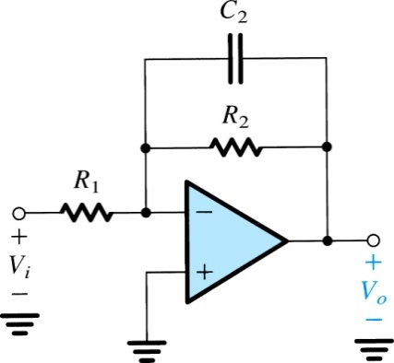**Example 2.4**

For the circuit in Fig. 2.23, derive an expression for the transfer function *Vo*(*s*)/*Vi*(*s*). Show that the transfer function is that of a low-pass STC circuit. By expressing the transfer function in the standard form shown in Table 1.2 on page 34, find the dc gain and the 3-dB frequency. Design the circuit to obtain a dc gain of 40 dB, a 3-dB frequency of 1 kHz, and an input resistance of 1 kΩ. At what frequency does the magnitude of transmission become unity? What is the phase angle at this frequency?

**Figure 2.23** Circuit for Example 2.4.

**Derivations you should know for the Exam:**

